DOCTOR APPOINTMENT AND QUEUE MANAGEMENT

1. Five Real-World Friction / Pain Points
# | Pain Point | What actually happens | Impact
1 | 🕐 Unpredictable Waiting Time | Patients arrive without knowing how many people are ahead of them and may wait 30–120+ minutes. | Frustration, wasted time, overcrowded waiting rooms
2 | 📞 Manual Appointment & Token Booking | Patients often call the clinic or physically visit to get a token. Receptionists maintain registers/WhatsApp messages. | Double bookings, missed calls, manual errors
3 | 👥 Overcrowded Clinics | Many patients arrive around the same time because they don't know the actual queue status. | Crowding, poor patient experience, pressure on staff
4 | 🔄 Queue Changes Are Hard to Communicate | A doctor may get delayed, take an emergency patient, or finish consultations faster/slower than expected. | Patients don't know whether to wait, come later, or leave
5 | 🗂️ Poor Coordination Between Roles | Receptionist, doctor, patient, and clinic admin may use separate systems or manual communication. | Information gaps, inefficient workflow, difficulty tracking appointments

2. Persona Matrix
You have 4 primary personas for this system.
Persona | Patient | Receptionist | Doctor | Clinic Admin
Role | Books appointment/token and waits for consultation | Manages appointments and queue | Consults patients and controls consultation flow | Manages clinic, doctors and overall operations
Main Goal | Get consultation without unnecessary waiting | Keep queue organized | See patients efficiently | Monitor clinic performance
Main Pain Point | Doesn't know actual waiting time | Manual queue management | Unpredictable patient flow | Lack of operational visibility
Current Behavior | Calls/visits clinic or waits physically | Register/phone/WhatsApp | Calls next patient manually | Uses spreadsheets/manual reports
Key Need | Live queue position | Simple queue dashboard | "Next Patient" workflow | Analytics & management dashboard
Important Feature | Live token + ETA | Token/queue management | Patient queue | Reports & user management
Frustration | "How long do I have to wait?" | "Which patient is next?" | "Who should I call next?" | "How is my clinic performing?"
Success Metric | Reduced waiting uncertainty | Faster queue handling | Smooth consultations | Better clinic utilization

3.FEATURE MAPPING
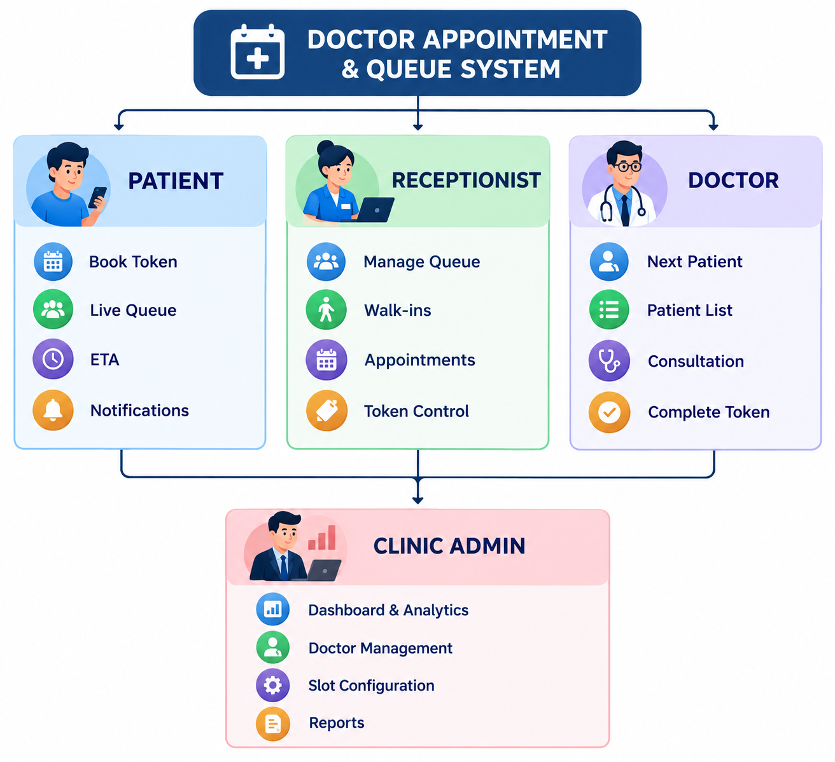

4.USERFLOW:
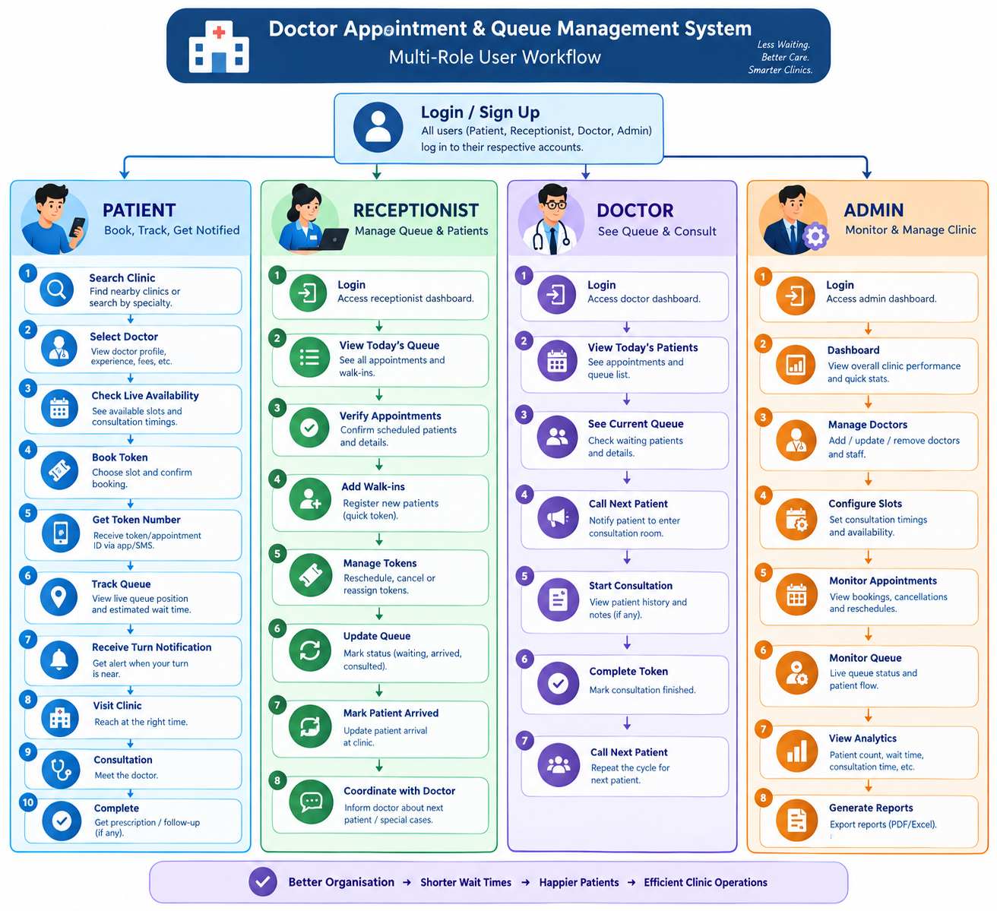

5.GAP ANALYSIS:
existing products such as Practo, Apollo 24|7, and Zocdoc show a few recurring workflow gaps. These are based on recent user reviews/complaints, so they should be treated as reported user experiences, not universal defects.
3 Major Feature Gaps / User Complaints
# | Gap | What users report | Opportunity for my product
1 | Appointment ≠ Real Queue Position | Users can book an appointment but may still face significant waiting because the actual clinic queue changes independently. | Live token + real-time queue position + estimated waiting time
2 | Poor Real-Time Communication | Users report doctor/clinic timing changes, cancellations, or appointment issues reaching them late or inconsistently. | Live status + instant notifications: “Doctor delayed 20 min”, “3 patients ahead”, “Your turn is next”
3 | Platform Booking vs. Clinic Reality | Reviews describe cases where the platform showed an appointment but the clinic/doctor's actual availability differed. | Clinic-controlled availability + receptionist dashboard + real-time token synchronization

5.MVP:
🎯 Core MVP
Book a token → join a unified queue → track your live position → get dynamic ETA → receive turn notification → consult the doctor.
MoSCoW Prioritization
Priority | Feature | MVP Scope
🔴 MUST HAVE | Role-based Login | Patient, Receptionist, Doctor, Admin
🔴 MUST HAVE | Doctor & Slot Availability | View available doctors and slots
🔴 MUST HAVE | Digital Token Booking | Patient gets a unique token
🔴 MUST HAVE | Unified Queue ⭐ | Online bookings + walk-ins in one queue
🔴 MUST HAVE | Live Queue Position ⭐ | Token #27 → 3 patients ahead
🔴 MUST HAVE | Dynamic ETA ⭐ | Estimated waiting time based on queue
🔴 MUST HAVE | Doctor Queue Dashboard | Doctor sees waiting patients
🔴 MUST HAVE | Call Next Patient | Doctor moves queue forward
🔴 MUST HAVE | Queue Status | Waiting → Called → Consulting → Completed
🔴 MUST HAVE | Receptionist Queue Control | Add/manage walk-ins and tokens
🟠 SHOULD HAVE | Real-time Queue Updates ⭐ | Patient screen updates when queue changes
🟠 SHOULD HAVE | Turn Notifications ⭐ | "Your turn is approaching"
🟠 SHOULD HAVE | Patient Check-in | Confirm arrival at clinic
🟠 SHOULD HAVE | Doctor Delay Update | Update ETA when doctor is delayed
🟡 COULD HAVE | QR Check-in | Scan QR to join/confirm queue
🟡 COULD HAVE | Basic Analytics | Patients served, average waiting time
🟡 COULD HAVE | Queue Prediction | Improve ETA using previous consultation times
🟡 COULD HAVE | Cancellation/Reschedule | Patient manages token
⚪ WON'T HAVE — MVP | Online Payments | Not required for queue problem
⚪ WON'T HAVE — MVP | Video Consultation | Outside the core problem
⚪ WON'T HAVE — MVP | Electronic Medical Records | Large additional scope
⚪ WON'T HAVE — MVP | Prescription Management | Not required for queue management
⚪ WON'T HAVE — MVP | AI Medical Diagnosis | Unsafe + unrelated to core problem
⚪ WON'T HAVE — MVP | Multi-hospital Management | Too much scope for 4 days

MVP architecture:

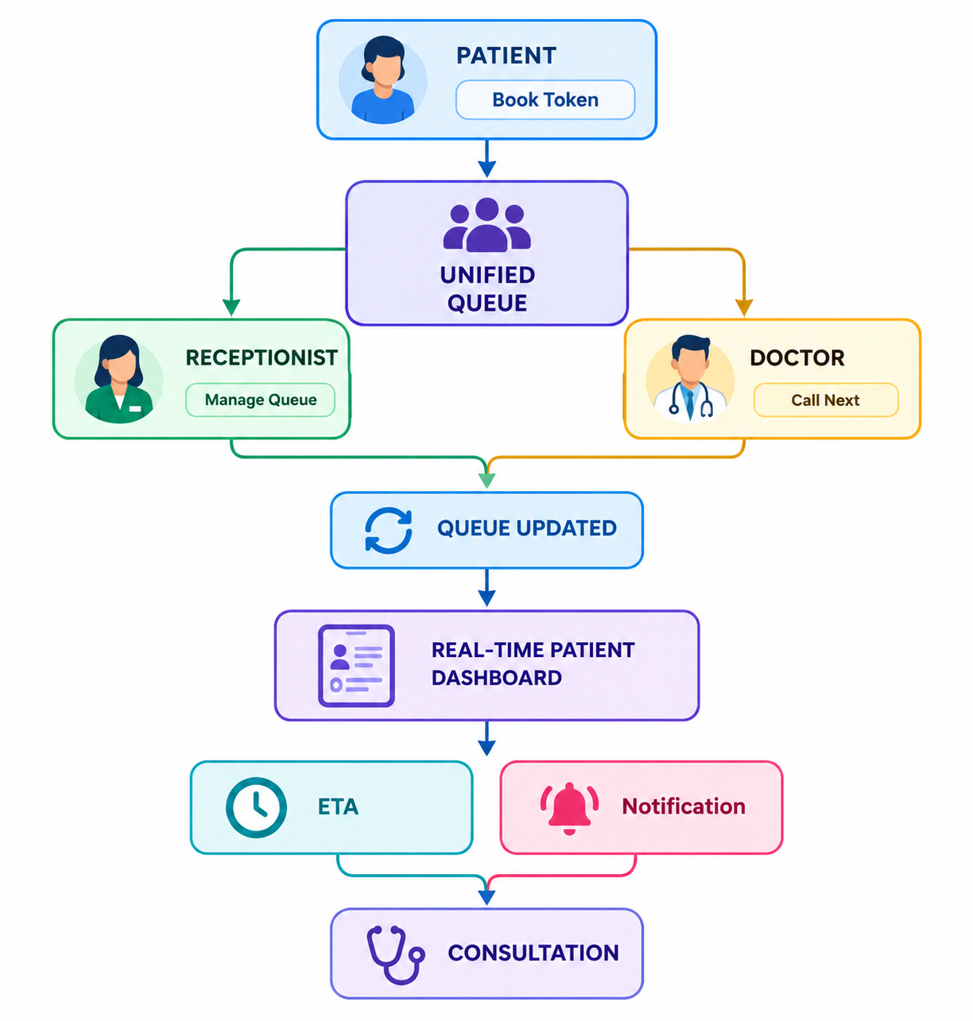
6.🏥 FINAL MVP MODULES & FEATURES
🔴 MUST HAVE — Core MVP
1. Authentication & Roles
- Login / Register
- Patient
- Receptionist
- Doctor
- Admin
- Role-based dashboards
2. Patient Module
- View doctors
- View available slots
- Book token
- Get token number
- View live queue position
- View patients ahead
- View ETA
- View appointment status
3. Appointment & Token Module
- Create appointment
- Generate unique token
- Prevent duplicate booking
- Token status:
  - Waiting
  - Called
  - Consulting
  - Completed
4. 🔄 Live Queue Management ⭐
The main feature of your project.
- Unified online + walk-in queue
- Add/remove patients
- Call next patient
- Skip patient
- Complete consultation
- Automatically update queue position
5. 👨‍⚕️ Doctor Dashboard
- Today's patients
- Current queue
- Call next
- Start consultation
- Complete consultation
- Mark skipped patient
6. 👨‍💼 Receptionist Dashboard
- Today's queue
- Add walk-in
- Manage tokens
- Verify patient arrival
- Monitor queue
7. ⏱️ ETA Engine ⭐
- Patients ahead calculation
- Estimated waiting time
- Dynamic ETA updates
- Doctor delay adjustment

🟠 SHOULD HAVE
8. 🔔 Real-Time Notifications
- Token confirmation
- Queue movement
- "Your turn is near"
- Doctor delay notification
9. 📱 Real-Time Patient Dashboard
Automatically update:
Token: #27
Position: 4
Patients Ahead: 3
ETA: ~24 min
Status: Waiting
10. 🏥 Patient Check-In
Patient can confirm:
"I have arrived at the clinic."
This prevents the doctor from calling patients who haven't arrived.

🟡 COULD HAVE — Hackathon Extras
11. 📷 QR Code Check-In ⭐
Generate a QR code for the appointment/token.
Flow:
Book Token
↓
Generate QR
↓
Patient reaches clinic
↓
Scan QR
↓
Patient Checked-In ✓
↓
Join/Confirm Queue
This is a good hackathon feature because it's easy to understand during the demo and connects directly to physical clinic workflow.
Important: Don't make QR scanning mandatory for the core booking flow. Keep a manual check-in fallback.

12. 🌐 Multi-Language Support ⭐
Start with:
- 🇬🇧 English
- 🇮🇳 Hindi
Add a simple language selector:
Language
┌──────────────┐
│ English ▼ │
└──────────────┘
For example:
English
3 patients ahead
Estimated wait: 24 minutes
Hindi
3 मरीज़ आगे हैं
अनुमानित प्रतीक्षा: 24 मिनट
Translate the UI labels, buttons, queue status, notifications, and basic patient-facing messages rather than trying to translate everything.
This is particularly useful for a small-clinic context where patients may have different language preferences.

13. 📊 Basic Analytics
Patients Today: 42
Completed: 31
Waiting: 7
Average Wait: 18 min
Keep it simple.

14. 🤖 Basic Queue Prediction
Instead of complicated AI, use historical consultation duration:
Average consultation = 8 min

3 patients ahead × 8
= ~24 min ETA
Later you could make this smarter using historical data.

